[student-01-415d3fa25c94@qwiklabs.net](mailto:student-01-415d3fa25c94@qwiklabs.net)

nA17K6kS6o3i

qwiklabs-gcp-00-f387e39bf558

qwiklabs-gcp-04-d46f76fe780c

Monitoring Multiple Projects with Cloud Monitoring

Project 1 already has a virtual machine (and you can look at it by going to **Compute Engine** > **VM instances**). You will create a virtual machine in Project 2, and then monitor both projects in Cloud Monitoring.

## Create Project 2's virtual machine

At the top of the screen, click on the dropdown arrow next to Project 1's name.



Make sure that you're on the **All** tab, then click on the name of Project 2 to go into it. 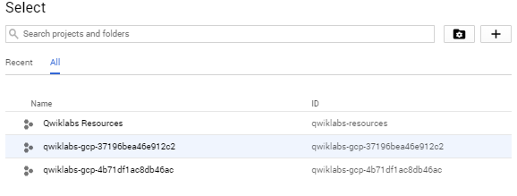

Select **Navigation menu** > **Compute Engine** to open the VM instances window.

Click **CREATE INSTANCE** to create a new instance.

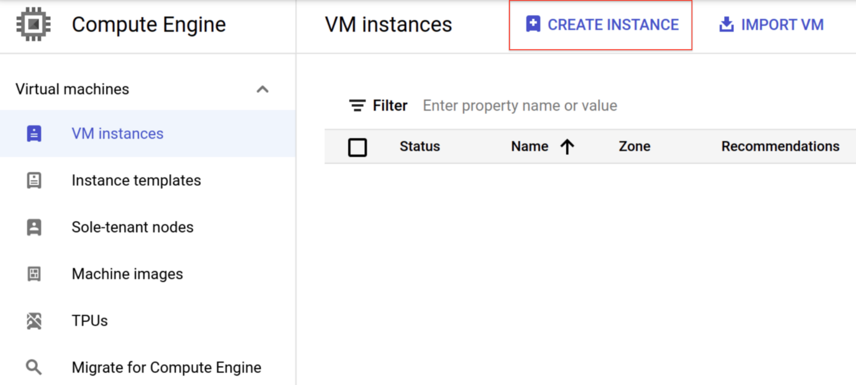

Name this instance **instance2**.

Leave all of the options at the default settings.

Click **Create**.

Now you have resources to monitor in both of your projects.

### **Test Completed Task**

Click **Check my progress** to verify your performed task. If you have completed the task successfully you will granted with an assessment score.

Create Project 2's virtual machine

Check my progress

Make sure that you are in Project 2 to proceed further in the lab

### **Create a Monitoring Metrics Scope**

Now set up a Monitoring Metrics Scope that's tied to your Google Cloud Project. The following steps create a new account that has a free trial of Monitoring.

1. In the Cloud Console, click **Navigation menu** > **Monitoring**.
2. When the Monitoring **Overview** page opens, your metrics scope project is ready.

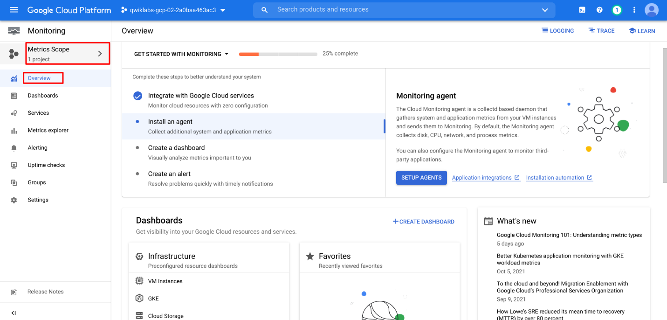

Now add both projects to your Cloud Monitoring workspace.

In the left menu, click **Settings** and then click **ADD GCP PROJECTS** in the GCP Projects section.

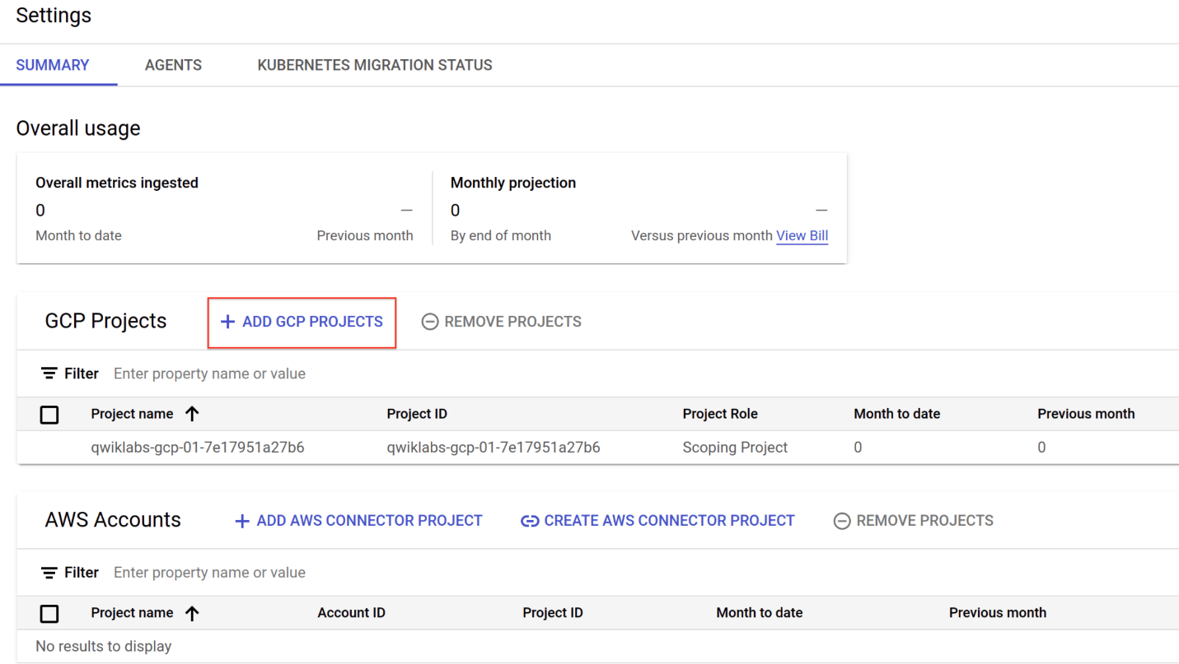

Select your GCP Project ID 1. Under **Select Scoping Project**, select **Use this project as the scoping project**. Click **ADD PROJECTS** then click **Confirm**.

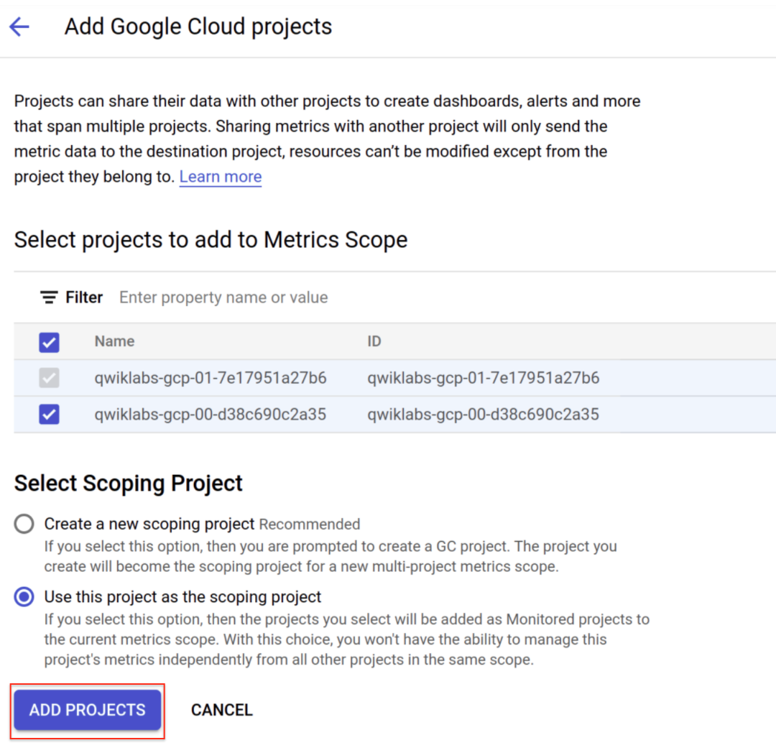

## Monitoring Overview

Click on **Overview** in the left menu. You'll be adding a lot of good information here as the lab goes along. First, you'll create a [Cloud Monitoring Group](https://cloud.google.com/monitoring/groups/) for visibility across both projects.

### **About Cloud Monitoring Groups**

Cloud Monitoring lets you define and monitor groups of resources, such as VM instances, databases, and load balancers. Groups can be based on names, tags, regions, applications, and other criteria. You can also create subgroups, up to six levels deep, within groups.

### **Create a Cloud Monitoring Group**

In the left menu, click **Groups**, and then click **CREATE GROUP**.

Name your group **DemoGroup**.

The **Criteria** is a set of rules that will dynamically evaluate which resources should be part of this group.

Cloud Monitoring dynamically determines which resources belong to your group based on the filter criteria that you set up.

* In the first dropdown field (Type), **Name** is selected by default.
* In the second dropdown (Contains), **Contains** is selected by default.
* In the third field (Value), type in "instance" since both of the instance names in both of your projects start with the word instance.

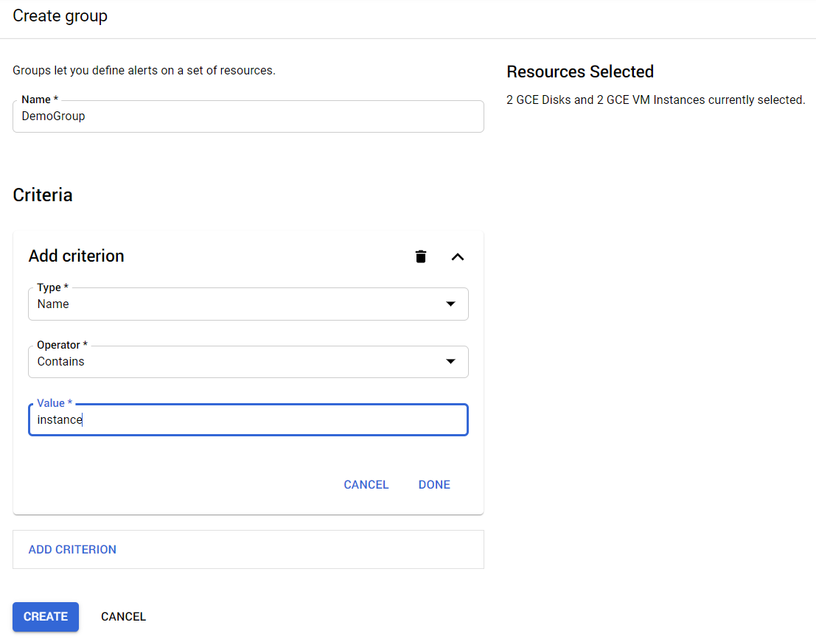

Click **DONE**, then click **CREATE**.

#### Test Completed Task

Click **Check my progress** to verify your performed task. If you have completed the task successfully you will granted with an assessment score.

Create a Cloud Monitoring Group

Check my progress

## Uptime Check for your group

Uptime checks let you quickly verify the health of any web page, instance, or group of resources. Each configured check is regularly contacted from a variety of locations around the world. Uptime checks can be used as conditions in alerting policy definitions.

In the left menu, click **Uptime Checks**, and then click **CREATE UPTIME CHECK**.

Create your uptime check with the following information:

**Title:** DemoGroup uptime check, then click **Next**.

**Protocol:** TCP

**Resource Type:** Instance

**Applies To:** Group, and then select **DemoGroup**.

**Port:** 22

**Check frequency:** 1 minute, then click **Next**.

Click **Next** again.

Put the slider in **off** state for **Create an alert** option in **Alert & Notification** section.

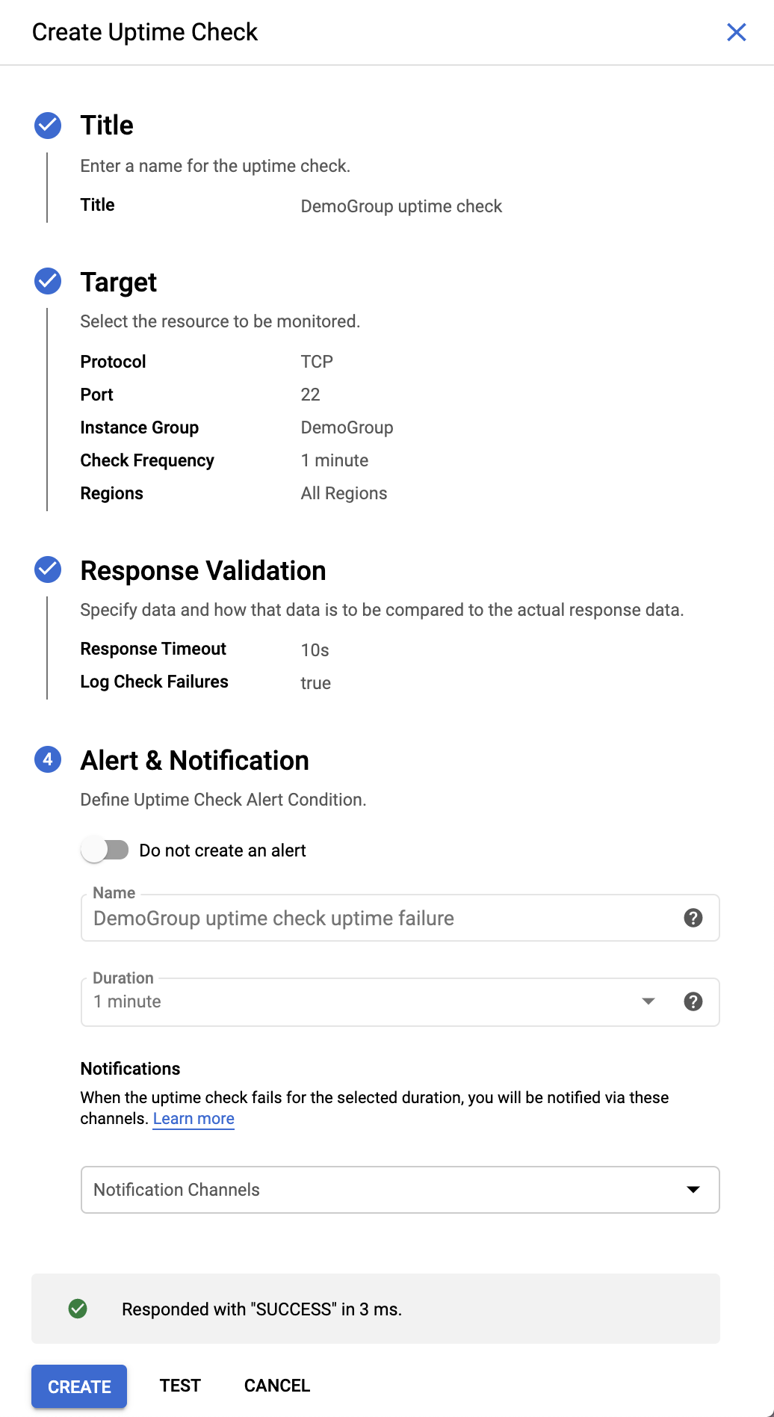

Click **TEST** to verify that your uptime check can connect to the resource.

When you see a green check mark everything can connect, click **CREATE**.

### **Test Completed Task**

Click **Check my progress** to verify your performed task. If you have completed the task successfully you will granted with an assessment score.

Uptime Check for your group

Check my progress

## Alerting Policy for the group

Use Cloud Monitoring to create one or more alerting policies.

In the left menu, click **Uptime Checks**. Click the three dots at the far right of your Display Name and click **Add alert policy**.

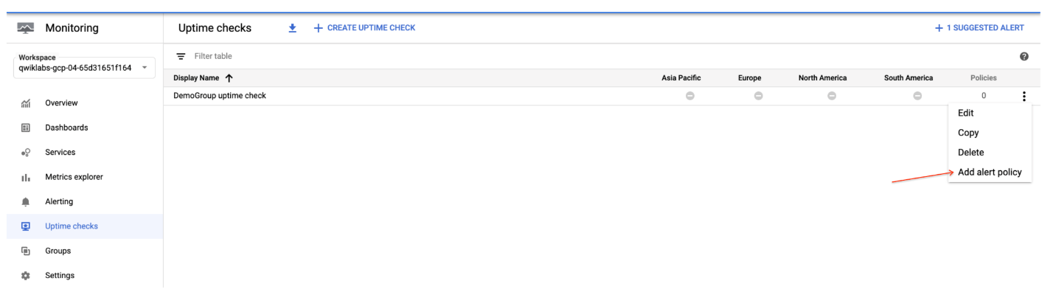

Click **ADD ALERT CONDITION**. Select the previously created "**-**" condition and click **DELETE ALERT CONDITION**.

In your **New condition**, click **SELECT A METRIC**.

In the Select a metric field, search check_passed and click **VM Instance > Uptime_check > Check passed**. Click **Apply**.

Click **ADD FILTER**, set the Filter to **check_id** and select **demogroup-uptime-check** as the Value. Click **DONE** and then **NEXT**.

Select **Metric absence** as Condition type and click **NEXT**.

Leave **Multi-condition trigger** default and click **NEXT**.

Turn off **Configure notifications**.

In the **Alert name** field, enter the Name as **Uptime Check Policy**. Click **NEXT**.

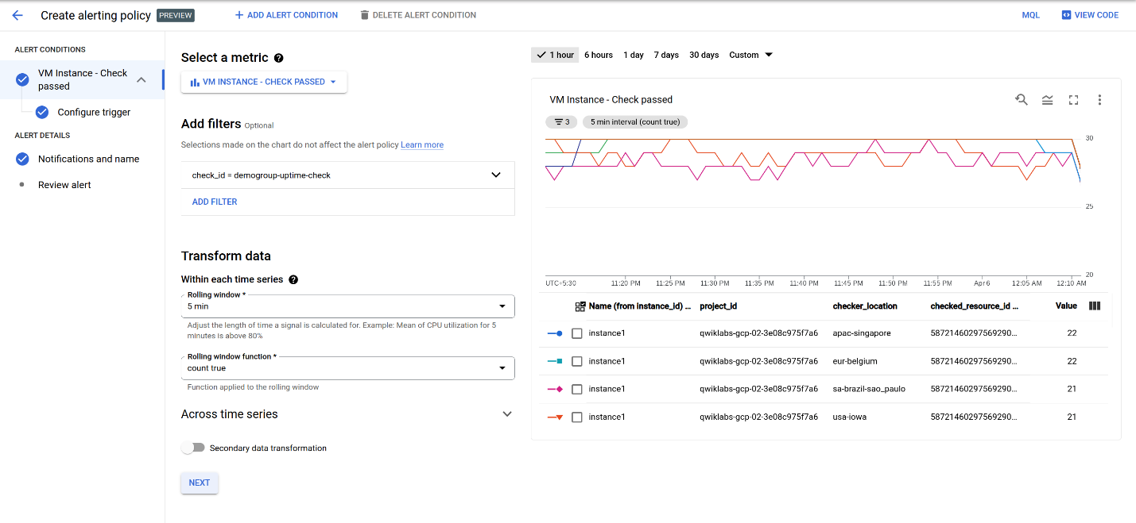

Click **CREATE POLICY**.

### **Test Completed Task**

Click **Check my progress** to verify your performed task. If you have completed the task successfully you will granted with an assessment score.

Alerting Policy for the group

Check my progress

## Custom dashboard for your group

Create a custom dashboard so you can monitor your group easily.

In the left menu, click **Dashboards**, and then click **CREATE DASHBOARD**.

Name your dashboard.

Click **Line** option in Chart library to add the first chart.

Leave the **Chart Title** as default.

In the **Resource & Metric** field, search **uptime** (compute.googleapis.com/instance/uptime) and click **VM Instance > Instance > Uptime**. Click **Apply**.

The dashboard should look like:

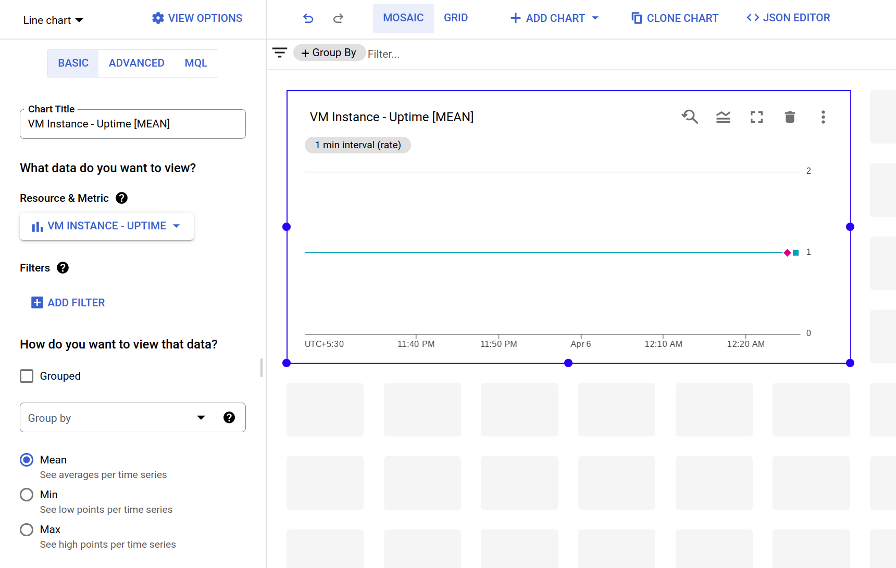

## Remove one instance to cause a problem

In the console, select **Navigation menu** > **Compute Engine**.

Check the box next to **instance2**, then click on the 3 vertical dots at the top of the page and click **STOP** , then click **STOP** again to turn off the machine.

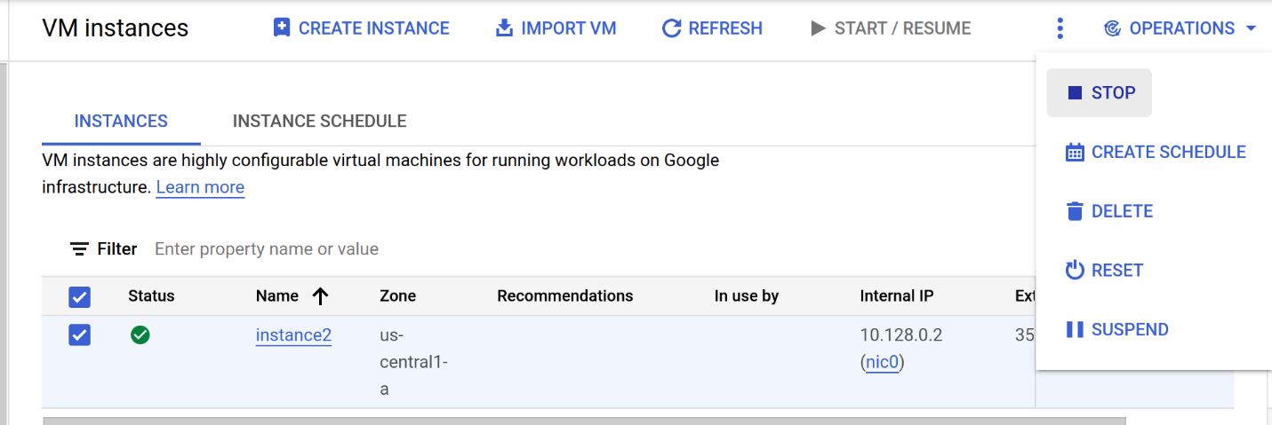

Wait a minute or 2 for the instance to stop and violate the uptime check you just set up. After a couple of minutes, turn your machine back on by clicking **START/RESUME**, then **START**.

Click **Navigation menu** > **Monitoring** > **Alerting** and refresh your browser. It may take a few more minutes to show that you have issues in the Summary section. Refresh until your screen looks similar to this:

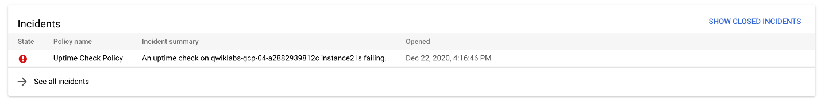

**Optional:** Using the left menu, look at **Dashboards** to view your custom dashboard. That provides details on both VMs. If you mouse over your chart, you can see which of your instances was stopped and restarted.

### **Incidents**

When the alerting policy conditions are violated, an "incident" is created and displayed in the Incident section.

Responders can acknowledge receipt of the notification and can close the incident when it has been taken care of.

In the **Incidents** section, click on the name of the alerting policy that was violated to go into it.

You've already **fixed** your problem by turning the VM back on, so the incident was cleared and you no longer see an incident in the Incidents section.

To see the cleared incident, scroll down and click on the **Show Closed Incidents** link.

Your incident should have a **Closed** status. You can read through the incident details.

You can also click on the **Uptime Check Policy** link to explore the metrics it gives you.

In several more minutes the Monitoring Overview page will all go back to green when the instance in Project 2 passes the Uptime Check.

## Test your Understanding

Below are multiple-choice questions to reinforce your understanding of this lab's concepts. Answer them to the best of your abilities.

Cloud Monitoring lets you define and monitor groups of resources with Cloud Monitoring Group.



True



False

## Congratulations!

You have monitored 2 Google Cloud projects in 1 Cloud Monitoring account, and responded to an incident with one of the instances in the Group.



### **Finish Your Quest**

This self-paced lab is part of the Qwiklabs Quest, [Google Cloud's Operations Suite](https://google.qwiklabs.com/quests/35). A Quest is a series of related labs that form a learning path. Completing this Quest earns you the badge above, to recognize your achievement. You can make your badge (or badges) public and link to them in your online resume or social media account. [Enroll in this Quest](https://google.qwiklabs.com/learning_paths/35/enroll) and get immediate completion credit if you've taken this lab. [See other available Qwiklabs Quests](https://google.qwiklabs.com/catalog).